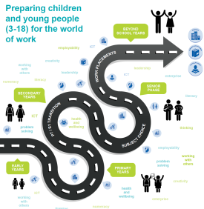
Career Education Standard 3-18
Reflection Tool on Learner Entitlements
Entitlements  Learners are entitled to: | Emerging Embedded | Comments
- experience a curriculum through which they learn about the world of work and job possibilities and which makes clear the strengths and skills needed to take advantage of these opportunities; | 1 5 10
- develop skills for learning, life and work as an integral part of their education and be clear about how all their achievements relate to these; | 1 5 10
- opportunities to engage in profiling that supports learning and the development of skills for work and future career choices; | 1 5 10
- a learning environment that recognises and promotes diversity and supports them to understand that it is everyone’s responsibility to challenge discrimination; | 1 5 10
- develop understanding of the responsibilities and duties placed on employers and employees; | 1 5 10
- develop understanding of enterprise, entrepreneurship and self-employment as a career opportunity; | 1 5 10
- know where to find information and access support making effective use of online sources such as My World of Work; | 1 5 10
- develop Career Management Skills as an integral part of their curriculum; | 1 5 10
- further develop CMS through the involvement of SDS Career Advisers in group and individual sessions as appropriate to personal circumstances and needs | 1 5 10
- have access to a broad range of pathways through their senior phase including learning opportunities leading to work-related qualifications. | 1 5 10

